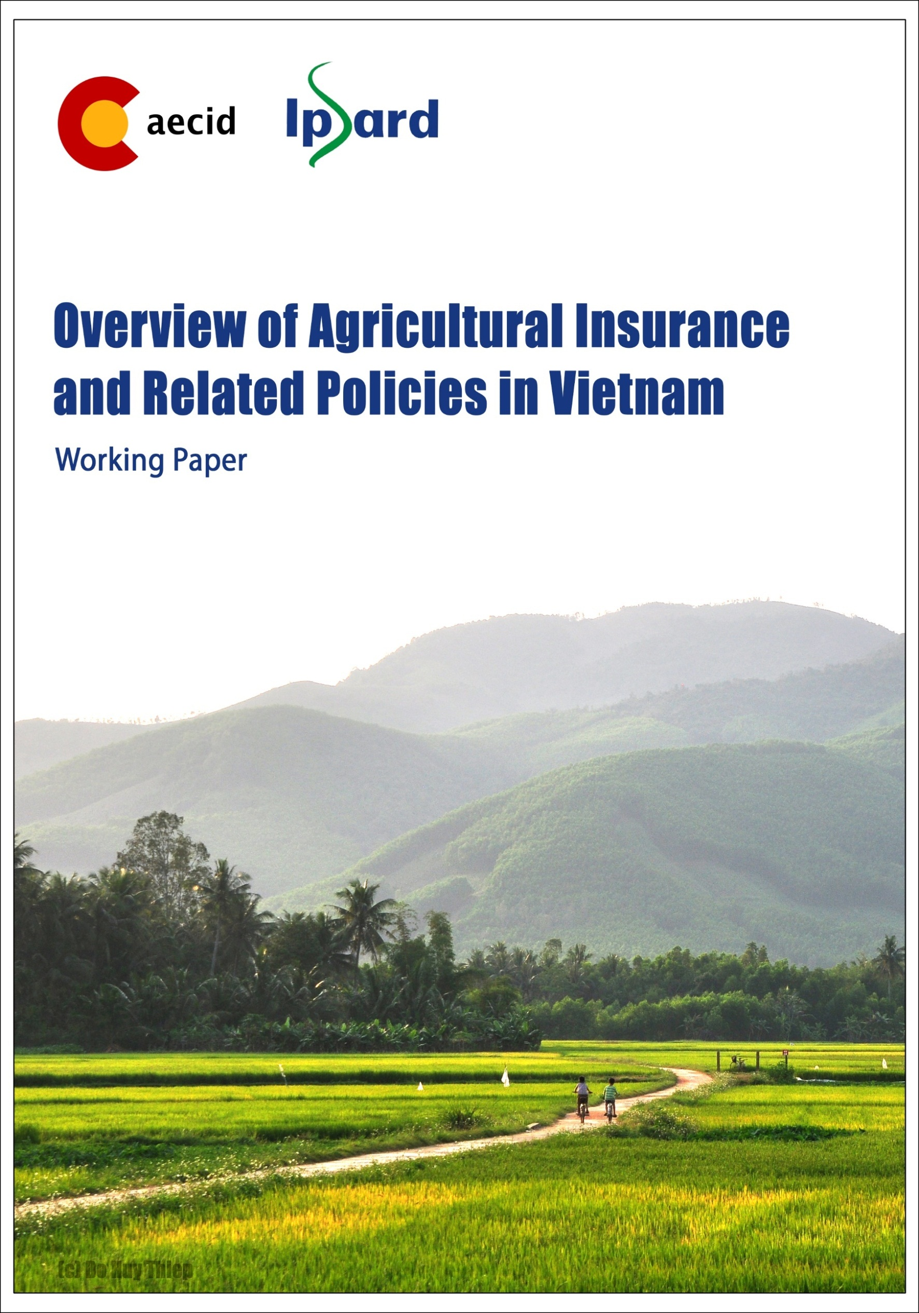
Assessing risks of farmers and agricultural production in Vietnam
Imprint
This publication is a joint undertaking by the Institute of Policy and Strategy for Agricultural and Rural Development (IPSARD) and the Spanish Agency for International Development Cooperation (AECID). IPSARD acts as a think tank on agriculture and rural development providing research-based information to support decision making processes in the sector.

Published by:
IPSARD

As at
February 2017

Design and layout:
Do Huy Thiep (IPSARD)

Authors
Tran Cong Thang
Dang Kim Khoi
Nguyen Thi aAn
Thai Van Tinh

Assessing risks of farmers and agricultural production in Vietnam
Author:
Tran Cong Thang, Dang Kim Khoi, Nguyen Thi Lan, Thai Van Tinh

Ha Noi, 2018

ACRONYMS 4
LIST OF TABLES 5
LIST OF FIGURES 6
I. INTRODUCTION 7
II. RISKS IN AGRICULTURE 7
2.1 Definition of agricultural risks 7
2.2 Risks and its effects on Vietnam’s agricultural production and rural households 9
2.2.1. Overview 9
2.2.2. Climatic hazard risk in Vietnam 13
2.2.3. Diseases and pest hazards 20
III. AGRICULTURAL RISKS GOVERNANCE IN VIETNAM 24
3.1. Before and during risk impact mitigation 24
3.1.1 Household adaptation and mitigation 24
3.1.2 Government support 26
3.2 Post-shock recovering capacity 28
3.2.1 Household recovering capacity 28
3.2.2. Government supports 31
IV. RISK ASSESSMENT CAPACITY IN VIETNAM 32
4.1 Limitted weather forcasting capacity 32
4.2. Opportunity to improve risk assessment capacity 33
V. CONCLUSION 33
VI. APPENDIX 34
REFERENCES 40

ACRONYMS

GSO | General Statistic Organization
VHLSS | Vietnam Household Living Standard Survey
VARHS | Vietnam Accessing Rural Household Survey
MARD | Ministry of Agriuclture and Rural Development
GDP | Gross Domestic Products
HPAI | Highly pathogenic avian influenza
OIE | World Organization for Animal Health
CSA | Climate Smart Agriculture
CAP | Center for Agricultural Policy
AI | Agricultural Insurance
IPCC | Intergovermental Panel on Climate Change

LIST OF TABLES
Table 1. Classification of risk facing agricultural producers 8
Table 2: The average value of loss caused by different types of risks (‘000 VND) 11
Table 3: Average number, in period term, of tropical cyclones that hit Vietnam 15
Table 4: Damage caused by disasters in Vietnam (1989-2013) 18
Table 5: Summary white spot disease outbreak and its damage in Vietnam 21
Table 6: Summary HPAI outbreak and its damage in Vietnam 22
Table 7: Summary Newcastle disease outbreak and its damage in Vietnam 22
Table 8: Summary Food and Mouth disease outbreak and its damage in Vietnam 23
Table 9: Summary Haemorrhagic septicaemia outbreak and its damage in Vietnam 23
Table 10: Household assets and shock related covariates 29
Table 11: Household risk copping mechanism 30
Table 12: Household risk copping mechanism by household categogies 31

LIST OF FIGURES
Figure 1: Share of commune affected by different type of risks 9
Figure 2: Share of commune affected at least one risk in a year and the structure of them by number of risk that commune affected 9
Figure 3: Percentage of household affected by different types of shocks 10
Figure 4: Household's average value of loss caused by different types of risks 12
Figure 5: Characteristics of households reporting shocks, 2016 (percentages, N=2,669) 12
Figure 6: Loss as share of net income by household characteristics (2016, N=2,669) 13
Figure 7: Number of disasters per year in South Asia (1970-2009) 14
Figure 8: Danger level of disaster across region and economic areas in Vietnam 14
Figure 9: Number of heat waves observed in Vietnam 16
Figure 10: Number of extreme rainfall in extended large area in Vietnam in the period of 1993-2012 16
Figure 11: Regional vulnerabilities caused by disasters in Vietnam 17
Figure 12: Economic losses (1990-2012) caused by disasters in Vietnam 18
Figure 13: Loss caused by natural disasters in the period of 2011-2016 19
Figure 14: Total outbreaks occurred during 2005-2016 by different diseases 21
Figure 15: Share of areas damaged on total planting paddy areas caused by common diseases 24
Figure 16: Selected CSA practices and technologies for some key agricultural products in Viet Nam 25
Figure 17: Delivery of meteorological and hydrological forecasts and warnings in Vietnam 27
Figure 18: Recover by shock type 28
Figure 19: Household copping machanism to shocks 29

I. INTRODUCTION
Agriculture in Vietnam plays an important role in its economy. After the ‘Doi Moi’ (renovation) policy in 1986, Vietnam has made a great jump from a country threatened by hunger to one of largest agricultural product exporters in the world. The agricultural export turnover increases from 3.4 billion USD in 2004 to 30.4 billion USD in 2014, accounting for 20.2% of total national exports (GSO, 2015). The national poverty rate fell from 37.4 per cent in 1998 to 9.8 per cent in 2013. Agriculture continues to be a key source of income for almost half of the population with its share of Gross Domestic Product (GDP) at 20 per cent and its share of employment at 47% in 2012 (GSO 2014).
Despite achieving significant results, the agricultural sector in Vietnam is facing with enormous risks due to new disease booming, climate change hazard and price volatility. For example, extreme weather events and natural disasters recently become more frequent and severe. In 2014, South Central Coast and Central Highland witnessed one of the worst droughts in the last 40 years causing serious impairment in 122,000 thousand ha of agricultural land (MARD, 2015). At the same time, extreme frost in Northern Upland killed thousands of cattle and destroyed thousands ha of rice and vegetable. In the future, the climate change is predicted to continue affecting agriculture negatively.
In addition, under new climate conditions, outputs of main crops such as rice and maize are projected to reduce and the growth and spread of pest will increase (FAO 2011; Zhu & Trinh 2010). In a gloomy assessment of IPCC (2007, p.10) about prospect of food production in the context of changing climate, “yields from rain-fed agriculture could be reduced by up to 50% by 2020”. In Vienam, about 590 thousand ha of rice could be lost because of inundation and saline instruction causing production reduction by 12 per cent in the Mekong River Delta and 24 per cent in Red River Delta (World Bank 2010). Millions of people living in low-lying areas would be forced to either elevate or abandon their homes, causing significant damage to the local and national economies (Dasgupta et al. 2011; Chaudhry & Ruysschaert 2007).
Under that situtation, this report, by assessessing the risks of farmers and agricultural production in Vietnam, will help the Vietnamese governement get the overall picture of risk of farmers before setting up any supporting machanisms such as linking the public partnership participation in AI. There are 3 main sections, excluding introduction and conclusion. The part 1 assesses the risks in agriculture; the part 2 overview the agriucltural risk governance and the part 3 covers risk assessment capacity in Vietnam.

II. RISKS IN AGRICULTURE

2.1 Definition of agricultural risks
There is a variety of definitions of risk given by scholars from different perspectives although most of them defined risks as probabilities of events causing any negative impacts or variability on living and business performance. According to Culp (2002), “risk can be defined as any source of randomness that may have an adverse impact on the market value of a corporation’s assets, net of liabilities, on its earnings, and/or on its raw cash flows”. The author indicated several types of risks including financial risk, peril, accident and hazard.
Williams and Schroder (1999c) suggested that there should be understanding on both sides of risk equation. Accordingly, risks should be understood, on the one hand, as both the chance of losing or of the potential failure. On the other hand, risks can be perceived as the opportunities to gain profits or future desirable outcomes. As the consequence, risk management should be considered as common way of life WB (2011) defined “Risk and uncertainty are ubiquitous and varied within agriculture and agricultural supply chains. This stems from a range of factors including the vagaries of weather, the unpredictable nature of biological processes, the pronounced seasonality of production and market cycles, the geographical separation of production and end uses, and the unique and uncertain political economy of food and agriculture sectors, both domestic and international”(Jaffee, Siegel and Andrews, 2010)
Risks in agriculture can be classified into different types of risk, such as production risk, marketing risk, institutional risk, personal risk and financial risk.
Table 1. Classification of risk facing agricultural producers
Type of risk | Definition | Factors affect
Production Risk | The chances at which the variation in production performance outcome, such as yield and total production occurs which are often outside the influence of the producer | Natural Disaster/ Climatic (Hail, frost, drought, wind ,fire, snow, pest infestation, flood); Geological (Earthquakes, volcanic eruptions);  Insect, disease, production method/technology
Marketing Risk | Includes “commodity price fluctuation, exchange rate variations, cost variations due to inflation – affecting input costs such as fuel and chemicals, the long-term trend of declining terms of trade – which can erode farm profits” | Commodity price fluctuation, exchange rate variations, inflation
Institutional Risk | Risk is referred to as the changes in government regulations and laws or risks occurring from the relationship between farmers and their counterparts, namely “counterpart risk” | Change in regutation,/law; Change in relationship between farmers and their counterparts
Personal Risk | Risk related to change in family health problem and family circumstances | Physical and mental health problem of both manager and stuff (Illness, injury, disability, epidemic disease)  Support from family and harmony  Family circumstances such as marriage breakdown and the retirement of older generation
Financial Risk | Including: credit risk and the risk of change in interest rate, declining equity and land value fluctuation  “The risk of non-payment or default by the buyer occurs whenever title (or control) is relinquished before payment is received” | Change in interest rate, equity and land value, payment method

2.2 Risks and its effects on Vietnam’s agricultural production and rural households

2.2.1. Overview
Vietnam presents an interesting case of risk prevalence in which farmer has been facing high probilility of risks and shocks. Figure 1 presents the frequency and structure of different type of risk occurred at commune level by years. According to the VHLSS commune survey, among approximately 2000 communes surveyed, risk caused by agricultural diseases occurred with highest frequency, showed by the highest share of commune affected and following by the risk caused by flood and storm. Drought and fire occurred less frequent while risk related to human disease is rarely seen, less than 5% of communes affected (Figure 1).

N=2219 (2005-2008); 2199 (2009-2010); 1716 (2011-2014)
Figure 1: Share of commune affected by different type of risks
Source: Caculated from VHLSS
Among six different type of risks, including fire, human diseas, flood, storm, drought and agricultural disease, approximately 30% of total communes surveyed was affected at least one of these risk in the period of 2005-2014 on average, ranging from 12% to 41%. The percentage of commune was affected at least one risk is low in 2005, 2011 and 2014 while this figure was double in the other years. Among those commune, most of them was affected one risk, accounting for approximately 80% and the two risks, accounting for about 15%. There was about 4% was affected by 3 risks and only small number communes was affected by more than 4 risk in a year (Error! Reference source not found.)

N=2219 (2005-2008); 2199 (2009-2010); 1716 (2011-2014)
Figure 2: Share of commune affected at least one risk in a year and the structure of them by number of risk that commune affected
Source: Caculated from VHLSS
For the time pattern of different type of risks, in general, the risks caused by flood and storm is normally occurred from May to November, drought was presented during from February to July and the other risks spread out in almost whole months of a year (Appendix, table 1). However, time pattern of these risks has been changing years by years and be difficult to project the time that risks occurred recently.
At household level, there are also different types of risk prevalence amongst the households, including natural disaters, pet and diseases, economic related risks such as crop price changes, shortage or imput price change, food or commodity price change, job loss, unsuccessful investment, land loss, and family member related risks such as illness, injuries or death, divorce, abandonment, or internal or extended family disputes. According to the VARHS (2006-2014), the percentage of household affected from pet and disease risks and natural disaster risks are higher than the risks related to economics and family members. On average, more than haft of household in the survey reported be affected from disease risks and nearly haft of household reported be affected from natural disasters. The percentage of household that be affected by economic related risks and shocks was ranging from 7% in the period of 2012-2014 to 24% in the period of 20010-2012 and the percentage of household that be affected by family member related risks and shocks was more or less than 20% in the whole period (2006-2014)

Figure 3: Percentage of household affected by different types of shocks
Source: Caculated from VARHS
On average, a household lost approximately 5-7 million VND per year in the period of 2006-2014, except for year of 2013. In 2013, the average loss of household caused by shocks is about more than 10 million due to the soar of the loss caused by shock related economics and family members (Figure 4). Average loss caused by economic and family member related risk and in 2013 was approximately 17 and 27 million VND, respectively.
Although the high percentage of household affected by diseases and natural disasters, the average loss caused by these shocks is relatively lower than those caused by the other shocks. The loss caused by natural disasters is lowest, normaly maintain around 2-3 mill per household per year, except for year of 2007 (5.4 million VND). The second lowest loss is caused by diseases, around 3-5 million VND, except for year of 2006 (9.4 million VND). The loss caused by family member and economic related risks, the value of loss is high and most fluctuated. In general, the highest loss is caused by family member related shocks, ranging from 6 million in the year of lowest loss (2008) to 27 million VND in the year of highest loss (2013). The loss caused by family member related risk was ranging from 4 to 17 million VND. However, there is integration of loss caused by different type of risks. For example, the natural disasters or disease also affect the change on food, inputs and commodity price, therefore cause the loss in economic related risk. The risk related to family members can cause negative impact on economic activities and agriculture production performation of households as well.
In addition, the range of loss is varied among households. This is showed by the high value of standard diviation, more than 2.5 times in compared to the mean (Error! Reference source not found.). The data also shows the increasing trend on household’s average value of loss in the period of 2006-2014, particularly the loss caused by family member related risk. By combining the data on average loss caused by different type of risks to the percentage of household affected by different type of risks, this shows that in the period of 2012-2014
Table 2: The average value of loss caused by different types of risks (‘000 VND)
 |  | 2006 | 2007 | 2008 | 2009 | 2010 | 2011 | 2012 | 2013 | 2014
Total | Mean | 7,543 | 5,866 | 5,044 | 5,376 | 7,396 | 7,596 | 7,181 | 10,192 | 7,250
 | Sd | 15,363 | 14,249 | 12,281 | 12,086 | 21,912 | 18,257 | 17,196 | 55,107 | 17,371
 | N | 105 | 1,309 | 1,121 | 1,268 | 787 | 1,228 | 979 | 1,068 | 644
Natural disaster risks | Mean | 2,971 | 5,405 | 3,595 | 3,575 | 3,546 | 3,218 | 2,015 | 3,993 | 3,048
 | Sd | 3,626 | 9,075 | 8,920 | 7,189 | 6,565 | 6,971 | 4,765 | 16,904 | 5,561
Disease risks | Mean | 9,398 | 4,340 | 5,858 | 3,603 | 4,792 | 5,432 | 4,796 | 3,669 | 4,242
 | Sd | 22,198 | 12,771 | 14,708 | 5,593 | 12,458 | 10,785 | 12,447 | 10,377 | 9,568
Economics related risks | Mean | 9,567 | 4,797 | 1,689 | 3,327 | 6,734 | 5,223 | 3,936 | 17,360 | 13,087
 | Sd | 17,787 | 14,756 | 7,015 | 7,064 | 12,230 | 29,256 | 11,749 | 62,608 | 38,141
HH family related risks | Mean | 6,847 | 8,098 | 6,085 | 9,220 | 13,254 | 14,934 | 15,830 | 26,792 | 14,463
 | Sd | 8,330 | 12,698 | 8,691 | 25,173 | 39,014 | 22,637 | 26,811 | 112,876 | 25,580

Figure 4: Household's average value of loss caused by different types of risks
Source: Caculted from VARHS
Note: Data of household shocks in 2006 is only collected in 7 first months of this year
Take a look deeply into the characteristic of household reporting shock based on the results of VARHS (2016), the non-Kinh households report substantial level of shocks as compared to the Kinh households (53 percent versus 23 percent). Also, the households who rely primarily on agricultural income report highest incidence of shocks (around 33 percent), against the wage/salary households (around 28 percent) and the non-wage/non-farm households (around 25 percent). Moreover, reporting of the shocks is higher for the households whose head has lower education level. It reduces subsequently for increasing levels of education, being the lowest for the households whose heads complete upper secondary schooling (22.4 percent).

Figure 5: Characteristics of households reporting shocks, 2016 (percentages, N=2,669)
Source: VARHS, 2016
Similar the trend of characteristic of household reporting shock, Non-Kinh households are found to be more exposed to shocks (as shown previously in Figure 5), and these households also suffer more losses as a share of net income against the Kinh households. In addtion, the households with heads being unable to read and write experienced greater proportion of losses relative to their net incomes. In the category of occupation, the results are consistent with the existing trends and it can be deduced that households who rely on agricultural income suffer higher proportion of losses as compared to other categories

Figure 6: Loss as share of net income by household characteristics (2016, N=2,669)
Source: VARHS, 2016

2.2.2. Climatic hazard risk in Vietnam
- Trend of climatic hazard risk
Vietnam presents an interesting case study about impact of climate change. Vietnam experiences high interannual rainfall variability, and both floods and droughts can occur in the span of a single year. The coastal region, particularly south-central, is subject to frequent droughts. The country’s long coastline is exposed to typhoons, which make landfall an average of 6–8 times per year and are accompanied by heavy rains and flooding, high tides and increased storm surges. With a large population living along the coastal lowlands and deltas and relying on natural resources as the main livelihood, Vietnam is identified as one of the most vulnerable country if climate change become worse (Yu at el. 2010; Di Falco, Veronesi, & Yesuf, 2011; Howden et al., 2007). According to the MARD, total annual loss caused by natural disasters is approximately 1.5% of GDP, in which agriculture is the sector be most serious effect.
Vietnam’s annual average temperature has increased by 0.5 °C nationwide and annual precipitation has decreased in the North and increased in the South (MONRE 2012a, b, 2013). There is evidence from observation in Vietnam of changes in climate extreme events in which the high frequency of storm and flood with extreme danger level occurred in Vietnam during last 30 years
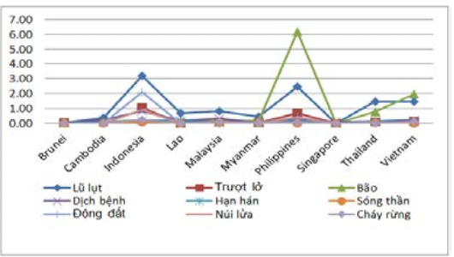
Figure 7: Number of disasters per year in South Asia (1970-2009)
Source: SREX, 2016
Figure 8: Danger level of disaster across region and economic areas in Vietnam
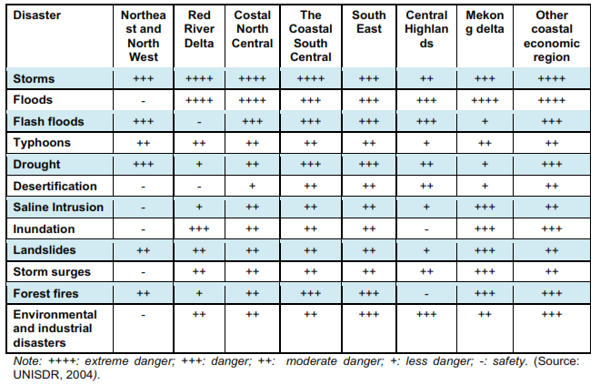
Firsly, in terms of tropical cyclones, there are annually on average about 12 tropical storms on the East Sea, of which about 45% form in the East Sea and 55% stem from the Pacific Ocean. There are about seven storms affecting Vietnam annually, five of which hit or directly affect the country’s mainland. The areas where storms or tropical depressions occur most frequently are in the middle of the Northern East Sea. In the central coastal area from 16°N to 18°N and in the northern coastal area from 20°N northwards, the storms or tropical depressions occur most frequently along the coastal region, with a storm or tropical depression landfall every 2 year in average. The number of tropical cyclones occurring in the East Sea seems to have increased slightly, while the number of cyclones affecting or hitting Vietnam’s mainland does not have an obvious changing pattern. Over the past decade tropical storms approaching Vietnam seem to move southwards, the number of very strong storms seems to increase and the storm season tends to last longer. Overall, storm impacts on the country seem to increase (MONRE 2012a, b).
Table 3: Average number, in period term, of tropical cyclones that hit Vietnam
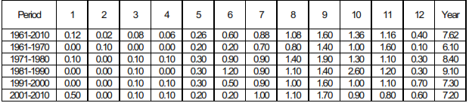
Source: Nguyen Van Thang et al (2010)
Secondly, although flood is a natural phenomenon which occurs nearly every year, flood partern have been changing along regions of Vietnam recently. The record of most river show an increase in the number of flood peaks. This increase might be caused by the infrastructure change in the river basin such as in the Dong Nai river in the South East or associated with climate change, however, except for some food peaks in some river due to major dam building or reservoirs that control flood (IMHEN & UNDP, 2015).
Thirdly, drought is classified as a commonly occuring disaster in Vietnam after flood and storm which cause great impact on agricultural production. Drought is one of the main causes of the shrinkage of the cultivation land area, the lowering the crop productivity and output, the reduction of production income and the increase of production cost and food price. Recent studies show that the possibility of higher frequency of occurrence of serious droughts in many part of Vietnam (Nguyen Van Thang et al 2010, 2013), particularly during winter-spring period (January to April) and sumer-autumn period (May to August) (MONRE, 2012). Winter drought spells mainly occur in the North, the South and the Central Highlands while summer draught spells occur in the Northern and Southern Central Vietnam. Winter draught spells have higher frequency than summer ones.
Beside the three common climate hazards, storm, flood and drought, Vietnam also have been facing many other weather and climate hazards that strongly affect agricultral production and farmer livelihood, including extreme seallevel rise, hoarfrost, frigid and damaging cold, extreme rainfall, heat waves, and risk of salt water intrusion. For example, in the past 16 years, the recorded number of heat waves increased sharply (Figure 9). On yearly average, about 25 surges of extreme rainfall is extended large area (Figure 10), and 20 to 55 frigid days in the North-West and North-East respectively, 15 to 25 days in the Northern Plain and 4 to 20 days in the Northnern Central Vietnam. For extreme sealevel, the recorded data show a tendency to rise of the seal water lever in most station.
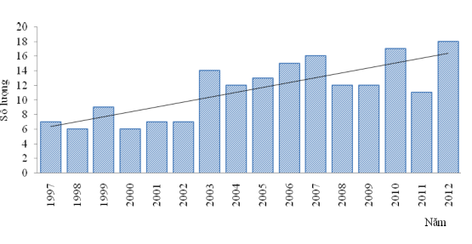
Figure 9: Number of heat waves observed in Vietnam
Source: SREX, 2016
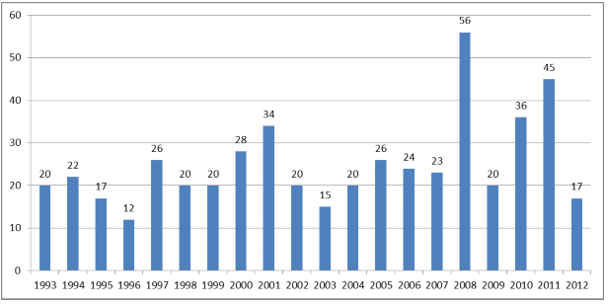
Figure 10: Number of extreme rainfall in extended large area in Vietnam in the period of 1993-2012
Source: SREX, 2016
According to SREX report, there is different regional vulnerabilities caused by disasters in Vietnam. For example: North Central and South Central is highly exposed to storm, flood and drought while Mekong River Delta is highly exposed to Flood, Sanline intrusion and sea level rise; North West and North East is highly exposed to Landslide. The vulnerabilities depend much on the intensity of extreme events, value and adaptive capacity of exposed objects to the hazard and natural factors such as gology, geomorphology, topography, and hydrology (Mai Trong Nhuan et al., 2011 & 2014)

Figure 11: Regional vulnerabilities caused by disasters in Vietnam
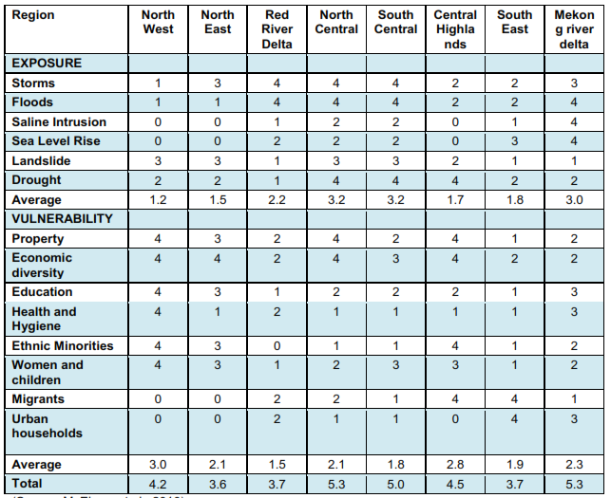
Source: SREX, 2016
- Disaster losses
Each year, on average, the region suffers damage in excess of US$4.4 billion a consequence of natural hazards. Annual average regional expected losses total US$4.4 billion, equivalent to greater than 0.2 percent of regional GDP. Myanmar, the Philippines, Viet Nam, Lao PDR, and Cambodia face particularly high annual average expected losses relative to the size of their economies, standing at equivalent to 0.7 percent or more of GDP
Economic losses from weather- and climate-related disasters have increased, but with large spatial and inter-annual variability. Among several types of disasters, Vietnam suffered most losses from tropical cyclones and floods, followed by drought and landslides (UNISDR, 2014) (Figure 12).
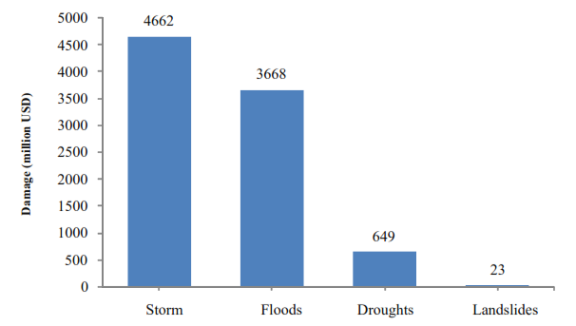
Figure 12: Economic losses (1990-2012) caused by disasters in Vietnam
Source: SREX, 2016
In the past 30 years, agriculture, including farming, livestock and fisheries are vulnerable to all climate change factors. Damage to agriculture, irrigation, transportation and fisheries due to disasters in Vietnam in the period 1989-2013 shows a decreasing trend but the number of deaths and total losses increasing. However, there is strong fluctuation in total damage caused by disaster each year. The difference between the year of highest loss in agriculture and the year of lowest loss recored in table 4 is up to more than 2 billion dong (1996 vs 1993).
Table 4: Damage caused by disasters in Vietnam (1989-2013)
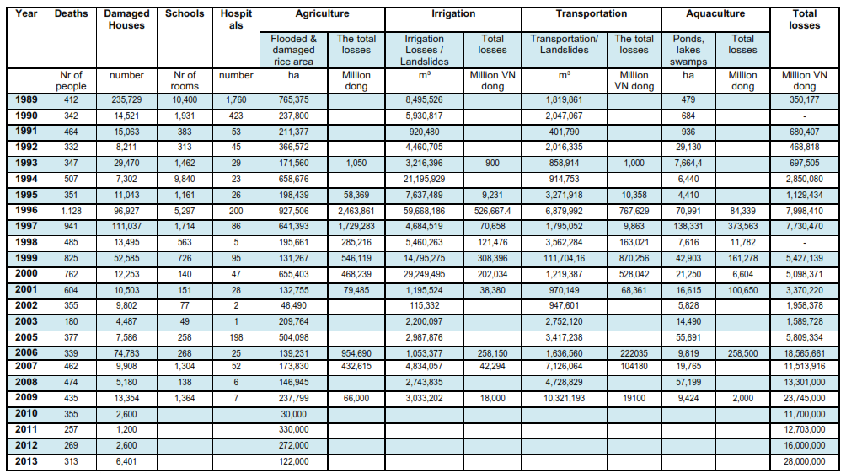
Source: SREX, 2016
Between 1976 and 2005, flooding and saltwater intrusion damaged 40,000 hectares of cropland and destroyed more than 100,000 ton of food (Mai Van Cong et al., 2009). Drought have damaged 74,000 hectares of coffee (UNEP, 2000), caused water shortages for over 120,000 hectares of arable land, mostly concentrated in the Central Highlands, Ninh Thuan and Binh Thuan province. In 2014, South Central Coast and Central Highland witnessed one of the worst droughts in the last 40 years causing serious impairment in 122,000 thousand ha of agricultural land (MARD, 2015). At the same time, extreme frost in Northern Upland killed thousands of cattle and destroyed thousands ha of rice and vegetable.
Drought also leads to saltwater intrusion, particularly in Mekong River delta, where the area of the cultivated land affected by saltwater intrusion is 676,000 hectares, or 40% of total 1.7 million hectares of agricultural land. In the dry season, the area of Mekong River Delta affected by tides leading to saltwater intrusion can be nearly 1 million hectares (SREX, 2015). According to MARD report, 100,000 hectares of the total 650,000 hectares of high-yielding rice cultivated in the coastal region of the Mekong River delta are at high risk of saltwater intrusion during the dry season every year (MARD, 2011). During the dry season in early 2016, the most severe drought and salt intrusion ever recorded in history has largely affected provinces in the Mekong River Delta (MRD) and in the South Central Coast (SCC), destroying 240 thousand hectare of rice and causing an income loss of 400 million USD (MARD 2016).

Figure 13: Loss caused by natural disasters in the period of 2011-2016
Source: GSO, 2017

If only estimating for rice and vegetable area damaged due to natural disasters, total rice and vegetable production area lost decreased in the period of 2011-2015. These figures, however, was rapidly increased in 2016 (GSO, 2017). In 2016, 528 thousand ha of rice and 150 thousand ha of vegetable were affected by natural disaster. Kien Giang, Ca Mau, Ben Tre and Bac Lieu are four provinces where was most heavily affected. In addition, according to GSO’s report (2017), natural disaster in 2016 affected approximately 50 thousand ha of aquaculture, 52 thousand heads of cattle, 1,680 thousand heads of poultry and more than 1 thousand tons of fishery products (Table 2, appendix).
- Future weather and climate hazard risk and its’ effects.
The climate projection indicates that: increase in Vietnam’s annual mean temperatures of 1°–2°C by 2050; and a 180 percent increase in the number of heat waves; and increases in annual rainfall across all regions by 2–7 percent, with more extreme precipitation variability between the dry and rainy season. By 2090, increases of 2–14 percent in the proportion of total rainfall falling during heavy events, particularly in northern regions, with increased risk of landslides in mountain areas; and rising sea levels of 28–33 cm (MONRE 2017)

Under new climate conditions, outputs of main crops such as rice and maize are projected to reduce and the growth and spread of pest will increase (FAO 2011; Zhu & Trinh 2010). Vietnam’s agricultural productivity is possibly reduced by 2-15% (Zhai & Zhuang, 2009). Climate extremes such as floods, drought, salinity, etc., can decrease rice production in Vietnam by about 2.7 million tons per year in 2050 (Yu et al., 2010). In a gloomy assessment of IPCC (2007, p.10) about prospect of food production in the context of changing climate, “yields from rain-fed agriculture could be reduced by up to 50% by 2020”. The rice crop is vulnerable to more variable rainfall patterns, inundation and waterlogging, and landslides. Research suggests production losses due to these risks could total 9.1 million tons annually by 2050. The agricultural productivity reduction is different along regions, for example, decrease in rice productivity is estimated about 4.3%-8.3% in the Mekong River Delate, 7.5-19.1% in the Red River Delta and the decline maybe higher in the Central Highlands. Other important crops are also vulnerable, with projected annual losses for sugarcane estimated at 3.7 million tons, maize at 1.1 million tons and cassava at 1.9 million tons. Rising sea levels threaten low-lying coastal zones and the Mekong and the Red River Deltas.
This situation might affect the food security. The Mekong Delta currently produces 13 percent (62 million tons) of the world’s rice, and projections suggest that 590,000 ha of these lands are at risk from inundation, translating into production losses of 2.7 million metric tons per year. Sea level rise also threatens major tributaries. In the next 30 years, around 1.6 million hectares, equivalent to 41% of total land area of the Mekong River Delta, could be affected by 4‰ salinity intrusion and 2.3 million hectares could be affected by 1‰ salinity intrusion (MONRE, 2012). Millions of people living in low-lying areas would be forced to either elevate or abandon their homes, causing significant damage to the local and national economies (Dasgupta et al. 2011; Chaudhry & Ruysschaert, 2007).
For fisheries, climate change threatens Vietnam’s fisheries sector, which accounts for 12 percent of total exports and is a source of livelihood for 4 million people. Higher temperatures can inhibit fish growth and survival rates and induce a northern migration to cooler waters. Currents closer to the coastline are warming faster, causing fish to migrate out of the range of artisanal fishing boats. Aquaculture production is concentrated in the Mekong River Delta, where sea level rise and associated surges are causing harmful saline intrusion into brackish and freshwater hatcheries.

2.2.3. Diseases and pest hazards
There was the decreasing trend in total outbreak of liverstock disease such as HPAI, FMD, Haemorrhagic Septicaemia and Newcastle while new outbreak of disease on aquaculture from 2012 and increasing sharply. There was recorded nearly 3,000 outbreaks of white spot disease on shrimp in 2016, increased by approximately 3.7 times of total outbreak in comparing to those number after 4 years.

Figure 14: Total outbreaks occurred during 2005-2016 by different diseases
Source: OIE, 2017
The fisrt notice of disease is on aquaculture recently. Although there are many different types of diseases threaten the Vietnam’s fishery industry, one of the big loss of aquacultural producers come from white spot disease. White spot disease (WSD) is a contagious viral disease of penaeid shrimp caused by the white spot syndrome virus (WSSV). From origins in Southeast Asia, the disease has spread throughout the world. The economic losses due to WSSV have been devastating, totaling at least 8 billion dollars since 1992. In Vietnam, the total white stop diseas outbreaks is about 2,711 in 2016 and the trend increasing during whole period of 2012-2016.
Table 5: Summary white spot disease outbreak and its damage in Vietnam
 | Total outbreaks | Susceptible | Cases | Deaths | Killed and disposed of
2016 | 2,711 | 2,461 | 1,912 | 1,617 | 843
2015 | 2,217 | 4,122 | 2,940 | 2,310 | 1,644
2014 | 2,205 | 20,800 | 17,100 | 14,500 | 4,500
2013 | 1,007 | 27,000 | 13,200 | 8,800 | 18,000
2012 | 740 | 28,600 | 24,200 | 19,000 | 5,200
Source: OIE, 2016
For livestock, HPAI has become entrenched in Vietnam since the H5N1 virus was first identified in the country in 2003, with outbreaks having occurred each winter since. HPAI causes direct losses to producers and other actors connected to the production and marketing of poultry through morbidity and mortality and the private costs associated with risk mitigation and/or coping measures during periods of production downtime and the need to reinvest in replacement birds. According to the data reported by OIE from the end of 2003 to 23 August 2010, Vietnam, Thailand and Egypt were the top three countries with severe impact due to HPAI both in terms of frequency of HPAI outbreak and magnitude of damage. After the hot time in 2004 and 2005, from 2006 until now, the total HPAI outbreak seem to be under controlled but there were thousands poultry killed and disposed or died each year (Table 6).
Table 6: Summary HPAI outbreak and its damage in Vietnam
 | Total outbreaks | Susceptible | Cases | Deaths | Killed and disposed
2016 | 12 | 15,825 | 6,065 | 4,655 | 11,170
2015 | 41 | 94,723 | 39,645 | 15,566 | 79,157
2014 | 49 | 140,371 | 73,027 | 46,892 | 93,479
2013 | ... | - | - | - | -
2012 | 22 | - | - | - | -
2011 | 38 | - | - | - | -
2010 | 47 | 64,994 | 25,801 | 21,228 | 36,272
2009 | 48 | 37,422 | 9,585 | 6,989 | 22,248
2008 | 78 | 71,011 | 28,387 | 24,179 | 45,757
2007 | 73 | 88,313 | 30,798 | 22,978 | 56,520
2006 | 36 | 19,788 | 10,896 | 9,274 | 8,663
2005 | 1,068 | 3,450,780 | 512,001 | 512,001 | 2,338,182
Source: OIE, 2017
Beside HPAI, Newcastle disease is the major constraint to improved Vietnam poultry production, especially for village or garden chickens - the important items in the economy of Vietnamese villages. Conventional Newcastle disease vaccines are used successfully in Vietnam to protect commercial chickens but still be limited in villages because of their heat sensitivity. The first official confirmation of the disease by laboratory diagnosis was not until 1949. Since then, Newcastle disease has been considered as the major fatal disease of chickens in Vietnam. Outbreaks are frequently reported in village chickens but until recently there were few firm data on incidence, morbidity, mortality and nature of the causative virus. According to OIE report (2017), this disease damaged more than 80 thousand poultry head (death, killed and disposed) in 2015.
Table 7: Summary Newcastle disease outbreak and its damage in Vietnam
 | Total outbreaks | Susceptible | Cases | Deaths | Killed and disposed
2016 | 78 | ... | 88,156 | ... | 28,401
2015 | 107 | ... | 165,894 | 9,559 | 70,996
2014 | 75 | ... | 84,719 | ... | 36,107
2013 | 83 | ... | 114,320 | ... | 38,966
2012 | 101 | 435,000 | 124,086 | 20,753 | 26,702
2011 | 200 | 475,000 | 147,105 | 67,535 | 8,356
2010 | 1,211 | 895,000 | 106,282 | 43,340 | 27,363
2009 | 939 | 4,867,385 | 114,815 | 59,261 | 23,559
2008 | 1,277 | 695,500 | 113,035 | 62,928 | 42,030
2007 | 1,351 | 1,109,090 | 1,069,351 | 81,874 | 14,682
2006 | 838 | 335,100 | 122,484 | 77,233 | 9,000
2005 | 122 | 230,230 | 113,656 | 49,892 | 27,085
Source: OIE, 2017

The other common diseases are Haemorrhagic septicaemia and foot and mouth diseas. These diseases also caused heavy losses among livestock such as cattle buffalo and pig. Although the trend of total outbreaks and deaths decreased in recent years, the patent of these diseases is still unpredicted. The total outbreaks recorded for Haemorrhagic septicaemia was really high in 2006-2008, however, the total livestock death was highest in 2011, with the total deaths of more than 10 thousand heads (Table 8 and Table 9).
Table 8: Summary Food and Mouth disease outbreak and its damage in Vietnam
 | Total outbreaks | Susceptible | Cases | Deaths | Killed and disposed
2016 | 36 | 40,500 | 1,107 | 1 | 2
2015 | 59 | 23,850 | 3,281 | 67 | 244
2014 | 58 | 44,104 | 1,613 | 114 | 89
2013 | 33 | 91,754 | 1,956 | - | 272
2012 | 34 | 2,500 | 1,028 | 105 | 554
2011 | 476 | 512,125 | 18,992 | 666 | 2,854
2010 | 280 | 219,866 | 9,521 | 681 | 358
2009 | 218 | 36,449 | 9,916 | 139 | 708
2008 | 39 | 867 | 468 | 2 | 71
2007 | 150 | 19,436 | 8,807 | 25 | 4,277
2006 | 489 | 90,567 | 40,173 | 1,738 | 1,804
2005 | 25 | 8,716 | 1,674 | 50 | 160
Table 9: Summary Haemorrhagic septicaemia outbreak and its damage in Vietnam
 | Total outbreaks | Susceptible | Cases | Deaths | Killed and disposed of
2016 | 95 | 0 | 5,039 | 259 | 0
2015 | 153 | ... | 7,278 | 307 | ...
2014 | 130 | ... | 7,791 | 747 | 0
2013 | 138 | ... | 9,278 | 1,019 | 0
2012 | 198 | ... | 65,260 | 7,387 | 0
2011 | 169 | 183,000 | 68,671 | 10,692 | 0
2010 | 247 | 865,922 | 57,369 | 6,969 | 0
2009 | 545 | 955,178 | 47,626 | 6,457 | 0
2008 | 2,472 | 256,723 | 46,536 | 5,313 | 0
2007 | 1,754 | 245,434 | 76,072 | 7,256 | 225
2006 | 1,312 | 312,185 | 44,122 | 1,603 | 0
2005 | 553 | 44,511 | 21,027 | 5,461 | 0
Source: OIE (2017)
For cultivation, changeable weather, including a prolonged hot spell, had created favou-rable conditions for pests and insects. According to the report of Plant Protection Institute, MARD, in the period of 1077-1978, there was recorded 12 different types of disease on coffee in the South. However, total type of diseases increased and up to 31 on coffee recorded in the period of 2006-2010.
Leaf Blast is the common disease that caused the highest damage on paddy during whole period recorded, from 2001-2010. Following leaf blast is brown spot, the total areas dammaged caused by this type of disase increased sharply, particularly from 2006 and caused the large damage on paddy recently. On average, share of areas damaged caused by leaf blast and brown spot on total planting paddy areas was about 16% in 2010. The other diseases affected less than 5% of total planting area per year (Figure 15).

Figure 15: Share of areas damaged on total planting paddy areas caused by common diseases
Source: The Ministry of Agriculture and Rural Development's Plant Protection Department

III. AGRICULTURAL RISKS GOVERNANCE IN VIETNAM

3.1. Before and during risk impact mitigation

3.1.1 Household adaptation and mitigation
At household level, to mitigate impact of climate change, CSA technologies and practices is considered as smart opportunities for farmers. CSA tehnologies and practices are expected to increase productivity as well as at least one of the other objectives of CSA (adaptation and/or mitigation). Hundreds of technologies and approaches around the world are classed as CSA. For xample, the most frequently suggested are those related to smart water and irrigation management or adoptation of improved crop varieties resistant to drought, floods or pests and diseases. Moreover, sustainable land management to reduce soild erosion in mountainous area and improves soil fertility by intercropping with leguminous species. For livestock, some practices suggested are integration of biogas technologies into pig production for efficient manure management and improved feed and fodder management.
However, most CSA technologies have a low or medium adoption rate in Viet Nam (<30% or between 30–60% of farmers of a specific production system). Some rice technologies have high adoption rates (>60%), such as shrimp–rice farming in the Mekong River Delta (practiced by small-scale farmers) and use of flood resistant varieties in the Red River Delta and Northern Mountain region (practiced by small, medium- and large-scale farmers). Among the few adopters, small- and medium-scale farmers are predominant in most technologies and regions, while some large-scale farmers can be found among the users of CSA technologies in pig production (in Midlands, Northern Mountains and Red River Delta), coffee (Central Highlands), rubber (Northwest, Central and Southeast Region) rice (Red River or Mekong Delta) and pepper (Central Highlands) (CIAT, 2017)
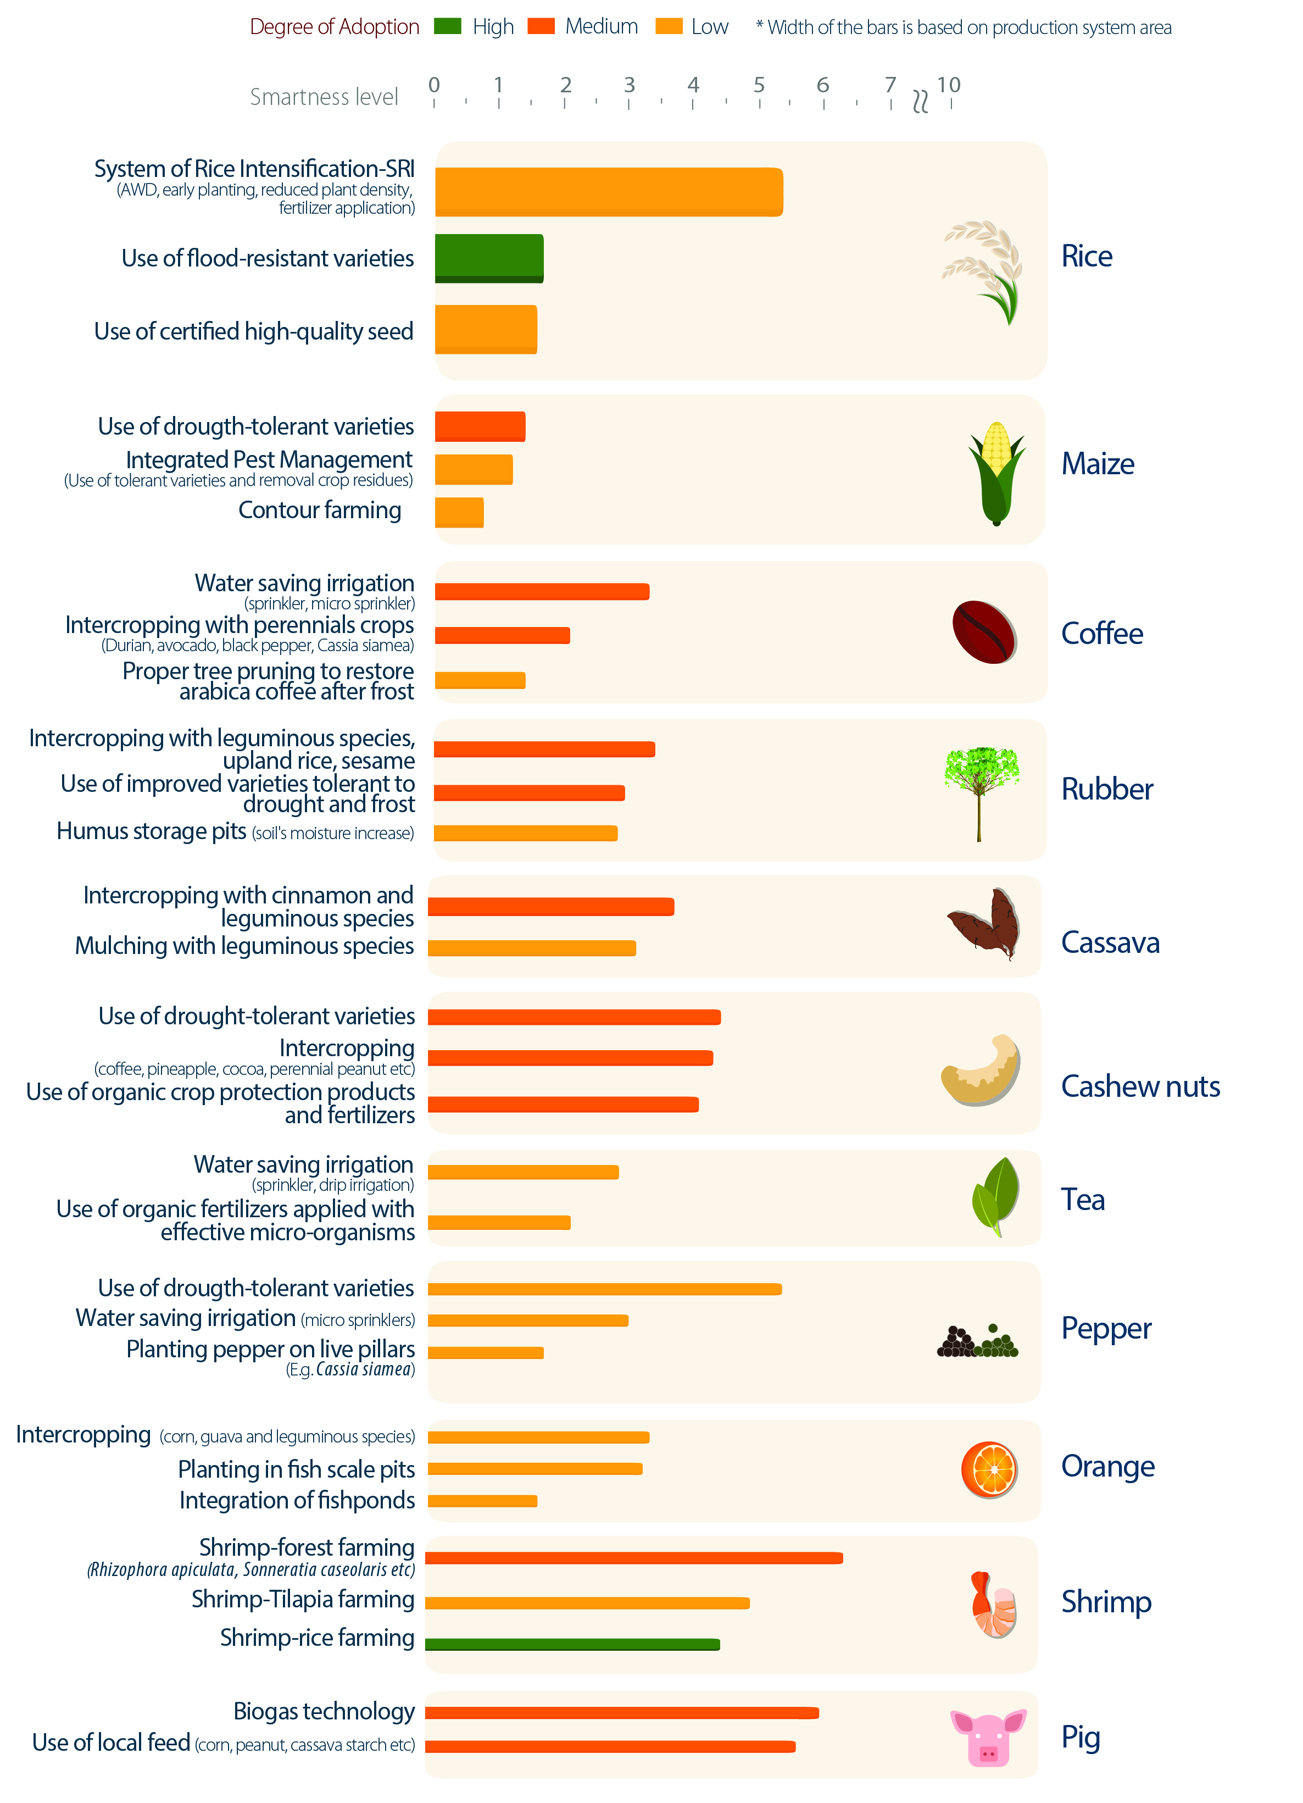
Figure 16: Selected CSA practices and technologies for some key agricultural products in Viet Nam
Source: CIAT, 2017
Beside CSA pracitice, many farmers in each region create their own way to apdapt to change in climate: For example, engineering measures that look for provide water for fields, such as drilling a well, building a pond, or repairing the drainage system. These measures help to remove salt water, to water dry fields and to remove alluvial soil after a flood; Or farm management measures refer to changing the seeding/harvesting calendar, changing seed varieties (using salt-tolerant or drought-tolerant varieties), and adjusting the use of inputs (fertiliser, pesticide, labours, etc). Among those adaptation measures, some households might not take any adaptation measures while some might use several at the same time.
In addition, to mitigate the risks from pet and disease in agricultural production, the most effective way is following the standard technical practice or appy smart or advance techniques, particularly VietGAP and linkage between production and consumption to create the Large Field Models. According to Agrocencus report (2016), at the survey time, Vietnam has 1,495 agricultural pruduction units received VietGAP certification, in which 540 certifications of households (36.1%), 551 certifications of farmer coorperation groups (36.9%), 199 certifications of farmer cooperatives (13.3%), 200 certifications of enterprises (13.4%) and 5 certifications of the other units (0.3%). For agricultural production integration, in 2016, Vietnam had 781 enterprises involved in agricultural production value change linkage, accounting for 20.3% of total agricultural, forestry and aquacultural enterprises, 2,469 farmer cooperatives, accounting for 35.5% of total cooperatives. Moreover, there were 5.3 thousand households involved in the linkage with VietGAP certified units and 619.3 thousand households involved in the linkage with Large Filed Models.

3.1.2 Government support
At the community level, technical assistance programs are designed to enhance farmers’ resilience. For example, extension staffs are sent to advise farmers about new technology or appropriate farming practices that may help them to adapt better to disaster or disease outbreak. Technical assistance can also be in the form of developing community-based pilot models to introduce new production techniques, for example growing rice with less water and fertilizer in cultivation or bio-security and vaccination in livestock.
In addition, enhancing early warning system plays an important role to mitigate impacts of disaster before it happens. Appropriate preparedness for disaster prevention is conditional upon adequate analysis of disaster risks and good early warning systems (FAO, 2011). The bodies responsible for providing early warning products in Vietnam include hydro-meteorological centres located in each province, regional hydro-meteorological centres and relevant divisions within the National Institute of Hydro-Meteorology/National Hydro-Meteorological Services of Vietnam (NHMS). Early warning information consists of weather, climate and hydrological forecasts and warnings. While meteorological and hydrological forecasts are issued on daily basis, specific warning information is provided in the event of severe disasters.
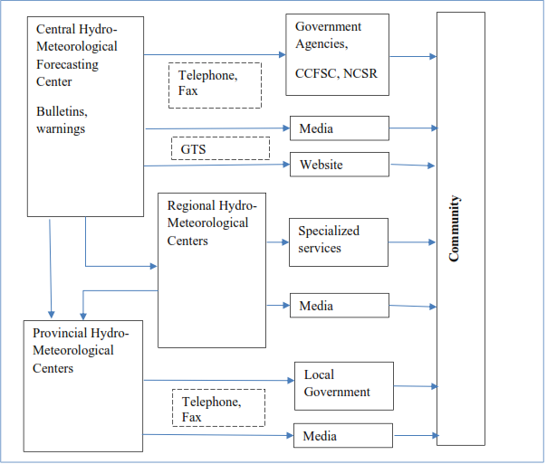
Figure 17: Delivery of meteorological and hydrological forecasts and warnings in Vietnam
Source: World Bank et al. (2012)
Early information flows from the national to the local level and reaches communities through a wide range of channels (Figure 17). Weather and hydrological data are available at provincial level and are synthesized/analysed by the NMHS. Forecasts and warnings are disseminated to central government authorities and the Central Committee on Flood and Storm Control. This information is also sent to local authorities at regional, provincial, district and commune levels in the form of bulletins and warnings. Information on warnings is provided to village leaders, who are expected to pass on the information to households within the village. Simultaneously, daily forecasts (and, in the event, warnings) are relayed to the community through media such as national and local radio, television. In addition, daily forecasts are published in newspapers and are posted in the website of NMHS. Since 2009, online forums have become available, allowing better interaction with the public and enabling prompt flows of information from centre to local levels in to enable timely decision-making (FAO, 2011).
Weather and climate warnings inform local farmers about the risk of and likely severity of a disaster, enabling them to prepare to take loss-prevention measures. The CAP’s survey results (2016) show that provision of early information significantly increases the likelihood that farmers’ will take adaptive action, as 44.2 per cent of adaptors received information before the specified disaster, compared to 25.7 per cent of non-adaptors. Loudspeakers and meetings at the commune or village office are among the most popular channels of information. When risky weather conditions are expected, warnings are most commonly conveyed to households through an official meeting. Messages communicated by loudspeaker are the second most common vehicle for transmitting alarms. Mass media is less effective in conveying information related to disasters: only 1.8 per cent of surveyed farmers report receiving information via television.

3.2 Post-shock recovering capacity

3.2.1 Household recovering capacity
According to VARHS (2010-2016), most of the households report fully or partial recovery from shocks. However, the recovering pattern from natural disaster and biological shocks has been changing toward the more serious by showing the decreasing trend in percentage of household recovered from natural disasters and biological shocks and increasing in percentage of household not recovered from natural disasters. The other shocks show the fluctuated pattern recovering by time.
Disaggregating by the types, households seem to recover completely or partially from natural disasters, biological shocks, crop price change shock, shortage or input price changes, and illness, injury or death. However, the shocks such as job loss, land loss, unsuccessful investment (though in small number) remain to be prevalent with higher percentage of households reporting to have been suffering from the effects until the survey was conducted.

Figure 18: Recover by shock type
Source: VARHS, 2016
Time to recover from shock is different to type of shock and the severity of shock. According to the Tran Van Quang’s survey result (2010), most of the shocks need nine months in average to recover. However, recovery time depends on type of shock, loss from shock, severity of shock and also on household coping strategies. Climate, agriculture, business and health shocks need longer time to recover compared to social shocks. Some shocks need several years to recover, while some never recovers because those shocks are too severe. High-severe shocks need more than 11 months to recover while medium-severe and low-severe shocks need six months and four months respectively. Among five types of shocks, business and health shocks need longest time to recover while climate and agriculture shocks need shorter time and social shocks need the shortest (Table 10)
Table 10: Household assets and shock related covariates
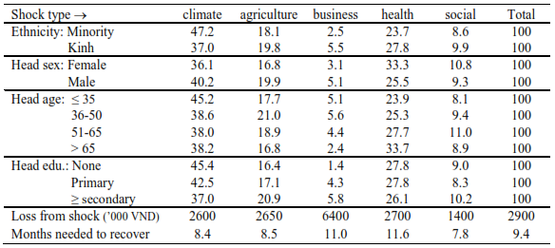Source: Tran Van Quang, 2010
Recovering capacity of household from shocks, including both time of recovering from shock also depends on the way that households deal with these shocks. Generally, most of the households were self-reliant in dealing with the shocks. There was slightly reducing in selt reliant machanism over time, from 93% to 90% of total households but still is dominat strategy, 90% on average. In addition, the informal mechanism was slightly decreasing while increasing in other mechanism used.

Figure 19: Household copping machanism to shocks
Source: VARHS
Amongst them, majority did nothing (39%-49%), and reduced consumption (38-62%). Following by is used savings (9-17%), or get assistant form relatives or friends (6-16%) (VARHS, 2006-2016). There is an interesting poit is household tend to increase get borrowing from relatives and friends while reduce borrowing from banks. There was only small percent of household got insurance payment, only approximately 1% in the period of 2006-2010 but increasing by the time and up to about 4% in 2014-2016 (VARHS, 2006-2016).
Table 11: Household risk copping mechanism
states | Did Nothing | Reduced Consumption | Sold Land, Livestock, or other | Assistance From Relatives | Assistance From Ngo, Govt. | Got Insurance Payment | Borrowed From Bank | Borrowed From Others | Used Savings
2006-2008 | 39.10 | 62.30 | 3.90 | 6.90 | 4.40 | 1.40 | 9.70 |  | 12.80
2008-2010 | 46.00 | 56.70 | 4.60 | 5.70 | 2.90 | 1.00 | 9.00 | 5.70 | 9.20
2010-2012 | 45.50 | 52.00 | 9.20 | 10.20 | 2.90 |  | 3.80 | 4.70 | 13.10
2012-2014 | 47.50 | 42.60 | 5.80 | 15.40 | 2.50 |  | 2.70 | 4.50 | 16.90
2014-2016 | 49.25 | 37.81 | 6.91 | 16.96 | 3.77 | 4.15 | 4.27 | 5.15 | 13.19
Source: VARHS
Take a deeply look at household in different categories of household income, occuptation, household head education and ethnicity. It is observed that the poorest households relied most on consumption reduction (40.46 percent) in dealing with the shocks. Sale of assets and getting assistance from friends and relatives was also high amongst them (7.51 percent and 4 percent); being higher than other income quintile, which indicates higher severity of shocks in poorest income groups. Also, the use of savings was less in the poorest income quintile (9.83 percent), which indicates that these households did not have much savings at their disposal for dealing with the shocks (VARHS, 2016). Among different categories of occupation, the agricultural households report higher percentages for reducing consumption, doing nothing or seeking help from family and friends in the event of shocks. The education of household head also seems to be an important characteristic towards risk coping mechanisms and it can be seen that households whose heads cannot read and write resort most to do nothing (51.39 percent), seek help from family or friends (18.06 percent), and reduce consumption (40.28 percent). Coping mechanisms across ethnicities do not differ much and is similar to the general trend of all the households taken together.

Table 12: Household risk copping mechanism by household categogies
 | Did Nothing | Reduced Consumption | Sold Land, Livestock, or other | Assistance From Relatives | Assistance From Ngo, Govt. | Got Insurance Payment | Borrowed From Bank | Borrowed From Others | Used Savings | Other
Total | 49.25 | 37.81 | 6.91 | 16.96 | 3.77 | 4.15 | 4.27 | 5.15 | 13.19 | 5.78
Total Income Quintiles
Poorest | 48.55 | 40.46 | 7.51 | 19.65 | 4.05 | 4.05 | 4.05 | 3.47 | 9.83 | 4.62
2Nd Poorest | 49.02 | 36.60 | 5.88 | 15.69 | 3.27 | 3.92 | 3.27 | 5.88 | 14.38 | 6.54
Middle | 49.34 | 39.47 | 6.58 | 14.47 | 3.29 | 3.29 | 1.97 | 4.61 | 17.11 | 6.58
2Nd Richest | 49.39 | 37.80 | 8.54 | 17.07 | 4.88 | 4.88 | 6.10 | 6.71 | 13.41 | 5.49
Richest | 50.00 | 34.42 | 5.84 | 17.53 | 3.25 | 4.55 | 5.84 | 5.19 | 11.69 | 5.84
Main income source
Wage/Salary | 49.80 | 36.11 | 6.94 | 16.27 | 3.97 | 4.56 | 4.37 | 4.96 | 13.69 | 6.94
Agricultural Income | 48.33 | 39.67 | 7.14 | 16.87 | 3.65 | 4.10 | 3.65 | 4.71 | 12.92 | 6.08
Non-Farm, No-Wage | 48.28 | 36.45 | 8.37 | 18.23 | 4.93 | 6.90 | 3.94 | 5.42 | 13.79 | 4.93
Others | 48.92 | 38.34 | 7.01 | 16.94 | 3.82 | 4.20 | 4.20 | 5.22 | 12.99 | 5.86
Education of the HH head
Cannot Read And Write | 51.39 | 40.28 | 2.78 | 18.06 | 5.56 | 2.78 | 2.78 | 1.39 | 13.89 | 8.33
Lower Primary | 50.98 | 36.60 | 7.84 | 15.69 | 2.61 | 3.27 | 3.27 | 3.92 | 10.46 | 6.54
Lower Secondary | 49.14 | 38.29 | 5.71 | 18.86 | 5.14 | 3.71 | 4.57 | 6.57 | 13.14 | 4.00
Upper Secondary | 47.00 | 37.00 | 8.50 | 15.00 | 2.00 | 6.00 | 5.50 | 5.00 | 15.00 | 8.00
Ethnicity
Non-Kinh | 49.05 | 38.57 | 7.14 | 16.19 | 4.29 | 4.76 | 2.86 | 3.81 | 15.24 | 5.24
Kinh | 49.32 | 37.54 | 6.83 | 17.24 | 3.58 | 3.92 | 4.78 | 5.63 | 12.46 | 5.97
Source: VARHS, 2016

3.2.2. Government supports
Getting assistance from Government is one of household risk coping machanisms. Government can use the direct or indirect payment to support household to recover from shocks. For example, the Government had been using direct payment as practically the sole measure to compensate farmers’ losses from natural disasters and disease epidemics. Four main legal documents support the measure is as following:
- Decision No. 719/QD-TTg of the Prime Minister (dated 5 June 2008) on support policies to prevent and combat diseases of cattle and poultry. It aims at providing financial support in terms of compensation to livestock producers as well as reducing pandemics.
- Decision No. 1442/QD-TTg of the Prime Minister (dated 23 August 2011) to amend and supplement a number of articles in Decision No. 719/QD-TTg.
- Decree 02/2017/ND-CP (dated 9 January 2017) on mechanisms and policy support to crop, livestock, aquaculture production recovery from damage caused by natural disasters and disease epidemics. The policy applies to individual farms and cooperatives. It set out the conditions for farmers to receive government support, the means of support and the amount.
- Decision No. 49/2012/QD-TTg of the Prime Minister (dated 8 November 2012) to amend and supplement Article 3 of Decision No. 142/2009/QD-TTg. The financial support was modified in accordance to the specified levels of indemnities.
With regard to direct support, local governments aslo provide farmers with production inputs such as drought-resistant seeds, stress-tolerant rice seeds while advocating a shift to the use of more resilient seed varieties. In addition, subsidised loan or relief funds are granted to farmers to help them respond to the risks and effects of disasters/diseases.

IV. RISK ASSESSMENT CAPACITY IN VIETNAM

4.1 Limitted weather forcasting capacity
The National Hydro-Meteorological Service (NHMS) of Viet Nam, like all the NMHS in other countries, has been given the mandate to protect man and society from the vagaries of weather, climate and water induced disasters and provide for ways the country can use weather, climate and hydrological in- formation in pursuing sustainable economic development, through the timely provision and issuance of timely, accurate and reliable information. The probability to get correct information in weather forecasting is depent on three major factors: technology, network of observation stations and information processing systems. There are however, numerous challenges, which could be classified as physical infrastructure, human resources, institutional arrangements, policy environment, and technology-related, among others. There include: (1) inadequate office infrastructure, observation/ monitoring networks, forecasting tools and systems, and financial resources; (2) insufficient manpower skills; (3) poor communication system, specifically for timely and fast data transmission and dissemination of forecasts and advisories.
In addition, in Vietnam, each observation station can only observe, record information within a radius of about 20 km. The distance between the two stations is separated from 50 km to 100 km, so at least 60 km between two stations can not grasp the information, the exact evolution of the phenomenon is happening. The number of monitoring stations is very low, leading to inadequate monitoring, so despite all the modern models in the world, the forecasted results in the models are not sufficiently reliable. Therefore, in addition to monitoring activities, National Center for Hydrometeorology should use other methods to determine such as satellite images, weather radar ... so the data has low accuracy
According to Hoang Duc Cuong (Nhue, 2017), the director of Central Hydrological Forecast Center, the most challenge of Vietnam’s meteorological and hydrological activities is that the forecast of heavy rain is only done in a short-range and in narrow-space due to the limmited rain monitoring networks and therefore less accurate rain information collected from radar, satellite. The NHMS’s existing forecasting system is not adequate to enable it to issue warnings on intense rainfall events that can trigger flash floods and landslides. Marine meteorological forecasts are also limited. Its technology for data processing, quality control and archiving is also old and needs upgrading. Moreover, in Vietnam, the forecasting process is take time, approximately 30 minutes because of the "manual" method. In general, to make a weather report, observers directly collect the information in the field, then encode and send it. This process is only take less than one minute in the advanced countries such as Korea, Japan and Thailand.

4.2. Opportunity to improve risk assessment capacity
Improvements in the NMHS that would reduce the damages due to weather and climate-related natural disasters on these sectors will have significant impacts on the overall economy. There also are a few significant opportunities which could enhance the provision of services required in order that the NHMS can effectively carry out its mandated role. These opportunities could also facilitate the acquisition of funds for equipments and facilities for the observing networks for monitoring hydromet parameters, robust communication system for real-time data assimilation and transmission, dissemination of forecasts and early warning advisories including data and information sharing, high-speed computing systems for data assimilation and numerical weather prediction, hiring of highly-skilled and competent staff and manpower, sustained interaction with users of forecast products and information, and close collaboration with other NHMSs in the region

V. CONCLUSION
Climate change presents a big challenge for agriculture production. Warming, increased pest incidence, and droughts are expected to lower rice yields, and below the level it would be in the absence of climate change. Sea level rise and salinity intrusion are expected to reshape the geography of rice production. The changing climate will probably drive rice production to areas that are especially suitable for multi-cropping. Coffee production, which is concentrated in the Central Highlands, could be hit hard by intensive droughts, higher temperatures, more temperature extremes, and increasing frequency of heat waves that cause increased evapotranspiration, and increased pest incidence. Livestock systems are predicted to suffer not just from temperature change but from disease-related impacts of climate change. However, aquaculture can be a promising solution, with adapted species and innovative management systems. There is evidence that rising temperatures and increased inundation during the wet season, could improve aquaculture productivity

VI. APPENDIX
Table 1: Number of commue affected by different risks
2005 (N=2291)
 | Fire | Human  diseases | Flood | Storm | Drought | Crop and  Livestock  diseases | Other | Total
Jan | 0 | 0 | 0 | 0 | 2 | 3 | 0 | 5
Feb | 0 | 0 | 0 | 0 | 2 | 11 | 0 | 13
March | 1 | 0 | 2 | 2 | 8 | 11 | 0 | 24
April | 3 | 0 | 2 | 3 | 7 | 15 | 1 | 31
May | 2 | 0 | 0 | 6 | 3 | 7 | 0 | 18
June | 0 | 0 | 5 | 7 | 11 | 5 | 1 | 29
July | 1 | 0 | 10 | 12 | 7 | 8 | 1 | 39
Aug | 0 | 0 | 12 | 12 | 2 | 6 | 1 | 33
Sept | 2 | 1 | 16 | 19 | 1 | 6 | 0 | 45
Oct | 5 | 0 | 30 | 14 | 2 | 17 | 2 | 70
Nov | 1 | 0 | 9 | 3 | 3 | 14 | 2 | 32
Dec | 1 | 0 | 5 | 1 | 0 | 12 | 2 | 21
Total | 16 | 1 | 91 | 79 | 48 | 115 | 10 | 360
2006 (N=2291)
 | Fire | Human  diseases | Flood | Storm | Drought | Crop and  Livestock  diseases | Other | Total
Jan | 2 | 1 | 0 | 1 | 1 | 13 | 3 | 21
Feb | 5 | 0 | 2 | 1 | 6 | 23 | 3 | 40
March | 10 | 2 | 2 | 3 | 16 | 32 | 1 | 66
April | 5 | 3 | 7 | 11 | 12 | 37 | 0 | 75
May | 4 | 3 | 4 | 22 | 17 | 25 | 1 | 76
June | 4 | 4 | 7 | 11 | 10 | 37 | 1 | 74
July | 2 | 1 | 16 | 17 | 7 | 19 | 1 | 63
Aug | 1 | 2 | 30 | 15 | 7 | 29 | 2 | 86
Sept | 0 | 1 | 28 | 24 | 1 | 12 | 1 | 67
Oct | 3 | 1 | 32 | 35 | 2 | 15 | 3 | 91
Nov | 4 | 1 | 13 | 52 | 2 | 18 | 8 | 98
Dec | 2 | 0 | 4 | 67 | 2 | 9 | 1 | 85
Total | 42 | 19 | 145 | 259 | 83 | 269 | 25 | 842
2007 (N=2291)
 | Fire | Human  diseases | Flood | Storm | Drought | Crop and  Livestock  diseases | Other | Total
Jan | 4 | 1 | 0 | 4 | 2 | 10 | 4 | 25
Feb | 7 | 4 | 2 | 4 | 13 | 39 | 6 | 75
March | 14 | 1 | 2 | 3 | 17 | 43 | 0 | 80
April | 9 | 3 | 7 | 18 | 15 | 42 | 4 | 98
May | 6 | 8 | 11 | 22 | 15 | 32 | 3 | 97
June | 2 | 5 | 17 | 23 | 12 | 24 | 1 | 84
July | 4 | 5 | 25 | 32 | 14 | 28 | 2 | 110
Aug | 5 | 4 | 65 | 41 | 7 | 22 | 1 | 145
Sept | 11 | 3 | 69 | 36 | 6 | 19 | 3 | 147
Oct | 15 | 4 | 123 | 61 | 4 | 47 | 3 | 257
Nov | 4 | 3 | 65 | 15 | 3 | 23 | 4 | 117
Dec | 6 | 1 | 3 | 3 | 3 | 27 | 11 | 54
Total | 87 | 42 | 389 | 262 | 111 | 356 | 42 | 1,289
2008 (N=2199)
 | Fire | Human  diseases | Flood | Storm | Drought | Crop and  Livestock  diseases | Other | Total
Jan | 6 | 1 | 7 | 1 | 4 | 20 | 106 | 145
Feb | 13 | 5 | 12 | 3 | 16 | 53 | 172 | 274
March | 8 | 2 | 4 | 11 | 6 | 33 | 13 | 77
April | 8 | 5 | 4 | 15 | 6 | 82 | 3 | 123
May | 9 | 6 | 4 | 20 | 4 | 36 | 2 | 81
June | 5 | 1 | 3 | 10 | 4 | 12 | 0 | 35
July | 5 | 4 | 8 | 8 | 0 | 11 | 2 | 38
Aug | 2 | 1 | 24 | 7 | 0 | 6 | 1 | 41
Sept | 0 | 0 | 5 | 2 | 0 | 0 | 0 | 7
Oct | 0 | 0 | 2 | 1 | 0 | 0 | 1 | 4
Nov | 0 | 0 | 1 | 0 | 0 | 0 | 0 | 1
Dec | 0 | 0 | 2 | 0 | 0 | 0 | 0 | 2
Total | 56 | 25 | 76 | 78 | 40 | 253 | 300 | 828
2009 (N=2199)
Tháng | Fire | Human  diseases | Flood | Storm | Drought | Crop and  Livestock  diseases | Other | Total
Jan | 0 | 0 | 1 | 2 | 4 | 6 | 4 | 17
Feb | 8 | 2 | 2 | 2 | 16 | 11 | 4 | 45
March | 13 | 4 | 0 | 9 | 11 | 15 | 1 | 53
April | 10 | 4 | 7 | 17 | 17 | 21 | 4 | 80
May | 7 | 4 | 11 | 10 | 13 | 15 | 2 | 62
June | 6 | 5 | 10 | 21 | 14 | 19 | 2 | 77
July | 5 | 7 | 19 | 29 | 10 | 21 | 2 | 93
Aug | 4 | 5 | 21 | 35 | 8 | 38 | 3 | 114
Sept | 2 | 2 | 92 | 110 | 5 | 24 | 1 | 236
Oct | 8 | 6 | 63 | 50 | 17 | 36 | 2 | 182
Nov | 8 | 3 | 51 | 21 | 5 | 9 | 1 | 98
Dec | 10 | 0 | 5 | 3 | 8 | 7 | 0 | 33
Total | 81 | 42 | 282 | 309 | 128 | 222 | 26 | 1,090
2010 (N=2199)
Tháng | Fire | Human  diseases | Flood | Storm | Drought | Crop and  Livestock  diseases | Other | Total
Jan | 6 | 0 | 0 | 1 | 2 | 5 | 0 | 14
Feb | 12 | 4 | 0 | 0 | 19 | 23 | 0 | 58
March | 9 | 4 | 4 | 5 | 30 | 24 | 0 | 76
April | 14 | 4 | 2 | 26 | 35 | 70 | 1 | 152
May | 10 | 8 | 2 | 27 | 49 | 41 | 2 | 139
June | 7 | 5 | 6 | 23 | 78 | 25 | 0 | 144
July | 11 | 9 | 16 | 16 | 22 | 48 | 1 | 123
Aug | 4 | 6 | 20 | 30 | 4 | 125 | 2 | 191
Sept | 4 | 3 | 11 | 10 | 4 | 55 | 0 | 87
Oct | 2 | 1 | 48 | 7 | 2 | 16 | 0 | 76
Nov | 1 | 1 | 15 | 0 | 1 | 7 | 0 | 25
Dec | 0 | 0 | 0 | 0 | 0 | 4 | 0 | 4
Total | 80 | 45 | 124 | 145 | 246 | 443 | 6 | 1,089
2011 (N=1761)
Tháng | Fire | Human  diseases | Flood | Storm | Drought | Crop and  Livestock  diseases | Other | Total
Jan | 0 | 0 | 0 | 0 | 0 | 4 | 1 | 5
Feb | 1 | 0 | 0 | 1 | 2 | 6 | 0 | 10
March | 3 | 0 | 1 | 1 | 4 | 7 | 0 | 16
April | 1 | 1 | 0 | 3 | 2 | 7 | 0 | 14
May | 1 | 2 | 0 | 1 | 4 | 3 | 0 | 11
June | 1 | 0 | 3 | 3 | 3 | 7 | 1 | 18
July | 0 | 0 | 3 | 7 | 1 | 3 | 0 | 14
Aug | 1 | 1 | 9 | 6 | 0 | 5 | 0 | 22
Sept | 3 | 2 | 21 | 5 | 0 | 7 | 0 | 38
Oct | 3 | 0 | 15 | 3 | 2 | 7 | 1 | 31
Nov | 5 | 1 | 8 | 2 | 1 | 5 | 1 | 23
Dec | 2 | 0 | 0 | 1 | 0 | 2 | 0 | 5
Total | 21 | 7 | 60 | 33 | 19 | 63 | 4 | 207
2012 (N=1761)
Tháng | Fire | Human  diseases | Flood | Storm | Drought | Crop and  Livestock  diseases | Other | Total
Jan | 2 | 2 | 0 | 1 | 1 | 6 | 2 | 14
Feb | 5 | 2 | 1 | 3 | 5 | 9 | 0 | 25
March | 4 | 1 | 1 | 11 | 5 | 13 | 0 | 35
April | 3 | 3 | 1 | 22 | 10 | 15 | 0 | 54
May | 4 | 2 | 5 | 20 | 15 | 14 | 1 | 61
June | 4 | 4 | 3 | 6 | 11 | 8 | 1 | 37
July | 8 | 3 | 9 | 18 | 4 | 20 | 1 | 63
Aug | 1 | 3 | 22 | 40 | 3 | 16 | 0 | 85
Sept | 2 | 1 | 26 | 24 | 4 | 9 | 2 | 68
Oct | 3 | 1 | 33 | 36 | 2 | 18 | 0 | 93
Nov | 4 | 1 | 9 | 3 | 0 | 9 | 2 | 28
Dec | 3 | 0 | 2 | 1 | 1 | 9 | 0 | 16
Total | 43 | 23 | 112 | 185 | 61 | 146 | 9 | 579
2013 (N=1761)
Tháng | Fire | Human  diseases | Flood | Storm | Drought | Crop and  Livestock  diseases | Other | Total
Jan | 2 | 0 | 2 | 1 | 0 | 5 | 2 | 12
Feb | 8 | 1 | 1 | 2 | 8 | 3 | 2 | 25
March | 5 | 3 | 0 | 13 | 17 | 20 | 1 | 59
April | 9 | 3 | 9 | 19 | 20 | 25 | 0 | 85
May | 4 | 1 | 11 | 19 | 11 | 14 | 3 | 63
June | 11 | 1 | 13 | 18 | 11 | 14 | 5 | 73
July | 2 | 1 | 19 | 28 | 8 | 11 | 4 | 73
Aug | 3 | 2 | 45 | 41 | 4 | 13 | 1 | 109
Sept | 2 | 2 | 39 | 48 | 2 | 9 | 2 | 104
Oct | 3 | 2 | 77 | 84 | 2 | 19 | 2 | 189
Nov | 3 | 0 | 68 | 23 | 3 | 11 | 1 | 109
Dec | 6 | 2 | 4 | 1 | 2 | 14 | 5 | 34
Total | 58 | 18 | 288 | 297 | 88 | 158 | 28 | 935
2014 (N=1761)
 | Fire | Human  diseases | Flood | Storm | Drought | Crop and  Livestock  diseases | Other | Total
Jan | 10 | 1 | 2 | 0 | 9 | 10 | 0 | 32
Feb | 11 | 1 | 0 | 5 | 4 | 14 | 7 | 42
March | 6 | 1 | 1 | 5 | 3 | 16 | 3 | 35
April | 13 | 3 | 1 | 13 | 5 | 4 | 1 | 40
May | 1 | 0 | 1 | 18 | 12 | 6 | 3 | 41
June | 2 | 0 | 11 | 6 | 14 | 6 | 0 | 39
July | 4 | 0 | 13 | 9 | 5 | 3 | 0 | 34
Aug | 5 | 0 | 6 | 10 | 4 | 8 | 1 | 34
Sept | 2 | 0 | 12 | 14 | 0 | 1 | 1 | 30
Oct | 2 | 0 | 1 | 1 | 0 | 1 | 0 | 5
Nov | 0 | 0 | 1 | 0 | 1 | 1 | 0 | 3
Dec | 0 | 0 | 2 | 0 | 0 | 0 | 0 | 2
Total | 56 | 6 | 51 | 81 | 57 | 70 | 16 | 337
Source: Caculated from VHLSS

Table 2: Agricultural production loss due to different types of natural disasters in 2016
Agricultural indicator | Unit | High tides, flooding | Rime, cold | Drought, salinity intrusion | Tornado, lighting, hail | Storm, flood, landslide | Total
Area of paddy | ha | 21731.2 | 60340.1 | 245495.8 | 5847.7 | 194328.2 | 527743.0
Area of rice seed | ha | 40.7 | 6982.2 | 0.0 | 11.9 | 6248.0 | 13282.8
Area of vegetables | ha | 2201.3 | 25929.9 | 31904.2 | 4427.8 | 85995.9 | 150459.1
Number of flowers, bonsai types | pot, tree | 150.2 | 35000.0 | 189877.6 | 6.0 | 3222118.0 | 3447151.0
Area of perennial crops | ha | 57.8 | 6046.6 | 38888.8 | 680.5 | 34754.3 | 80428.0
Area of annual crops | ha | 86.3 | 517.9 | 0.0 | 1891.7 | 78692.6 | 81188.5
Area of concentrate fruit | ha | 354.4 | 5668.1 | 38888.8 | 285.6 | 36014.0 | 81210.9
Area of existing forest | ha | 0.0 | 51027.6 | 0.0 | 16.1 | 5261.8 | 56305.5
Area of scattered forest | ha | 0.0 | 0.0 | 0.0 | 45.3 | 95741.5 | 95786.8
Seedlings damaged | ha | 0.0 | 0.0 | 48.0 | 4.8 | 20565.1 | 20617.9
Seeds damaged | ton | 0.0 | 0.0 | 0.0 | 0.0 | 35.1 | 35.1
Food drifted, wet and damaged | ton | 206.3 | 0.0 | 0.0 | 7.8 | 11205.8 | 11419.9
Area of homestead land eroded, buried | ha | 0.0 | 0.0 | 0.0 | 0.2 | 1698.0 | 1698.2
Area of salt field buried, damaged | ha | 0.0 | 0.0 | 0.0 | 0.0 | 309.9 | 309.9
Salt damaged | ton | 0.0 | 0.0 | 0.0 | 0.0 | 4691.1 | 4691.1
Salinity cultivated area | ha | 0.0 | 0.0 | 0.0 | 0.0 | 208.0 | 208.0
Area of ​​production stopped due to lack of irrigation water | ha | 0.0 | 0.0 | 22149.5 | 0.0 | 0.0 | 22149.5
Other damages on agriculture, forestry and salt production  (*) | million dong | 0.0 | 0.0 | 0.0 | 0.0 | 106.0 | 106.0
Cattle died, swept away | head | 276.0 | 36678.0 | 6528.0 | 74.0 | 32318.0 | 75874.0
Poultry died, swept away | head | 17781.0 | 60239.0 | 1809.0 | 2221.0 | 1777976.0 | 1860026.0
Livestock others died, swept away | head | 0.0 | 2766.0 | 0.0 | 0.0 | 135593.0 | 138359.0
Feeds for livestock are swept away, buried, damaged. | ton | 0.0 | 0.0 | 0.0 | 0.0 | 644.8 | 644.8
Stables and equipment for livestock damaged | million dong | 0.0 | 0.0 | 0.0 | 0.0 | 228.0 | 228.0
Other damages on livestock (*) | million dong | 0.0 | 0.0 | 0.0 | 0.0 | 400.0 | 400.0
Area of aquaculture traditional fish |  | 81.9 | 4226.6 | 194.1 | 21.1 | 22654.2 | 27177.9
Area of aquaculture catfish | ha | 0.0 | 0.0 | 0.0 | 0.0 | 6.2 | 6.2
Area of aquaculture shirmp | ha | 9.0 | 0.0 | 0.0 | 0.0 | 6185.3 | 6194.3
Area of aquaculture scallop | ha | 0.0 | 0.0 | 0.0 | 0.0 | 4674.8 | 4674.8
Area of aquaculture others | ha | 0.0 | 1740.3 | 68813.9 | 0.0 | 733.6 | 71287.8
Cage for aquaculture | 100m3/ cage | 0.0 | 50.0 | 0.0 | 1.0 | 2964.8 | 3015.8
Means of fishing | piece | 10.0 | 0.0 | 0.0 | 9.0 | 1437.0 | 1456.0
Fishing gear, communication equipment | million dong | 0.0 | 0.0 | 0.0 | 0.0 | 100.0 | 100.0
Storm shelter construction | number | 0.0 | 0.0 | 0.0 | 0.0 | 1.0 | 1.0
Other damages on fishery (*) | million dong | 0.0 | 0.0 | 0.0 | 0.0 | 2298.0 | 2298.0
Source: GSO 2017

REFERENCES
1. Vietnam, GSO (General Statistics Office). Various years. Statistical Yearbook of Vietnam. Hanoi: GSO.
2. IPCC (2007). Climate Change 2007: The Physical Science Basis. Contribution of Working Group I to the Fourth Assessment Report of the Intergovernmental Panel on Climate Change.
3. World Bank. 2010. Vietnam: Economics of Adaptation to Climate Change. Washington, DC.
4. Zhu, T., and M. V. Trinh. 2010. Climate Change Impacts on Agriculture in Vietnam. In Proceedings of the International Conference on Agricultural Risk and Food Security, June 11–12, 2010, Beijing
5. World Bank. 2011. Rapid Agricultural Supply Chain Risk Assessment: A Conceptual Framework.
6. Culp, C. L. (2002). A vocabulary of Risk The Art of Risk Management: Alternative Risk Transfer, Capital Structure, and the Convergence of Insurance and Capital Markets (pp.185). Canada: John Wiley & Sons.
7. Inc. Williams, J., & Schroder, W. (1999c). Introducing risk Agricultural Price Risk Management The principle of commudity trading. United Kingdom: Oxford University Press.
8. See Jaffee, S., Siegel, P., and Andrews, C. (2010). Rapid Agricultural Supply Chain Risk Assessment: A Conceptual Framework. The World Bank. Washington. D.C.
9. MONRE. 2012a. Climate change scenarios and sea level rise for Vietnam, Hanoi.
10. MONRE. 2012b. National strategy on climate change, Hanoi.
11. MONRE. 2013. Documentation to assess the impact of climate change and adaptation measures, Hanoi
12. Howden SM. 2007. Adapting agriculture to climate change.
13. Di Falco S, Veronesi M, Yesuf M. 2011. Does adaptation to climate change provide food security? A microperspective from Ethiopia.
14. IMHEN &UNDP. 2015. SREX Viet Nam 2015.
15. UNDP, 2000: Drought Disaster Study (Summary Report), Report by the Center for Technology Transfer on Water and Hydraulic Structures Exploitation (CTTWHSE) for United Nations Development Programme, Vietnam under project UNDP VIE/ 97/002 - Support to disaster management system in Vietnam.
16. UNISDR, World Bank, WMO, NHMS, GFDRR, 2015: Country Assessment Report for Vietnam - Strengthening of Hydrometeorological Service in Southeast Asia.
17. Fan Zhai and Juzhong Zhuang. 2009. Agricultural Impact of Climate Change: A General Equilibrium Analysis with Special Reference to Southeast Asia. ADBI Working Paper Series.
18. Chaudhry, P & Greet Ruysschaert. 2007. Climate Change and Human Development in Vietnam. Human Development Report 2007/2008. Occasional paper.
19. Tran Quang Van. 2012. Household behavior and post-shock recovery in Vietnam
20. Kim Nhue. 2017. Disaster alert capacity in Vietnam. https://baomoi.com/nang-cao-nang-luc-du-bao-canh-bao-thien-tai/c/23582641.epi

